**Student name: Trevor Cardoza SMC username: Tmc12**

Instructions: Fill out your full name and SMC username above. Answer each question in its respective following space. **Give a sufficient yet succinct answer for each question and show results / figures / tables / graphs on this same sheet when appropriate or explicitly requested.** After completion, rename and save this file as **“Assignment 3_BUSAD 137_*your full name*” in either MS Word (.docx or .doc) or PDF (.pdf) format** then upload and submit it **together with the completed Bayside.xlsx Excel file** on Moodle by the due date. No other file formats will be accepted. A late or email submission will NOT be accepted.

**Total possible points: 100 points**

1. **Integer Linear Optimization Model (50 points in total)**

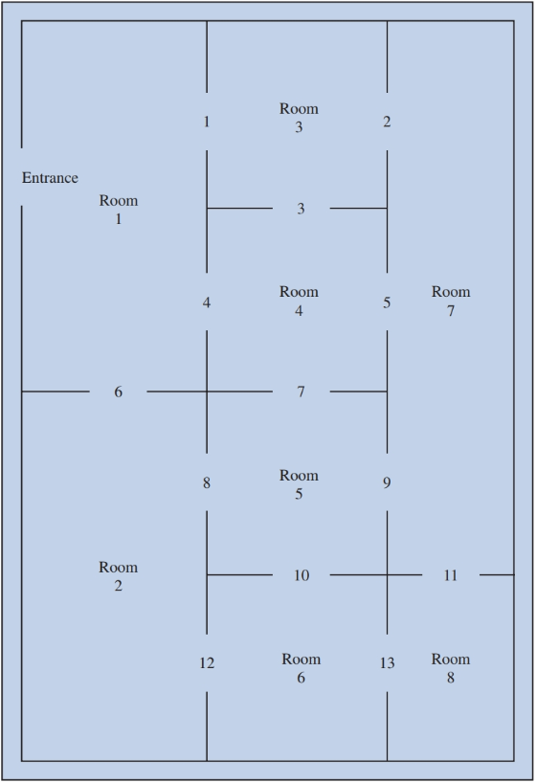The Bayside Art Gallery is considering installing a video camera security system to reduce its insurance premiums. A diagram of the eight display rooms that Bayside uses for exhibitions is shown in the following figure; the openings between the rooms are numbered 1–13. A security firm proposed that two-way cameras be installed at some room openings. Each camera has the ability to monitor the two rooms between which the camera is located. For example, if a camera were located at opening number 4, rooms 1 and 4 would be covered; if a camera were located at opening 11, rooms 7 and 8 would be covered; and so on. Management decided not to locate a camera system at the entrance to the display rooms. The objective is to provide security coverage for all eight rooms using the minimum number of two-way cameras.

1.1 What is the integer linear program for this problem expressed in the mathematical form? Write down the entire mathematical model in the following space including the explicit and implicit constraints. Let xi be a binary decision variable if a camera is located at opening i (i = 1, 2, 3, …, 12, 13). (10 points)

Min x1-13

x1-13>= 1

1.2 Develop an Excel spreadsheet model for this integer linear program by completing the missing parts indicated by the bordered cells **except the shaded cells** on the worksheet tab named “Model (original)” in the provided **Bayside.xlsx** file and find the optimal solution using Excel Solver. Generate an answer report on a new worksheet tab named “Answer for original model”. How many two-way cameras the Bayside Art Gallery needs to purchase according to the optimal solution? (Note: remember to submit the completed Bayside.xlsx file alongside with your answer sheet on Moodle.) (20 points)

4

1.3 At which openings should these two-way cameras be located according to the optimal solution from part 1.2? (5 points)

Openings: 1, 5, 8 and 13

1.4 Suppose that management wants to provide additional security coverage for room 7. Specifically, management wants room 7 to be covered by **two cameras**. How would the model you formulated in part 1.1 have to change to accommodate this new policy restriction? Write down **only the updated part(s)** in the original model from part 1.1 in the following space. (5 points)

x7>= 2

1.5 Create a new worksheet tab named “Model (updated)” in your same **Bayside.xlsx** file. In this new worksheet, create an **updated spreadsheet model** derived from the original spreadsheet model in part 1.2 to solve part 1.4 using Excel Solver and generate a new answer report named “Answer for updated model”. With the new policy restriction specified in part 1.4, determine how many two-way camera systems will need to be purchased and at which openings they will be located according to the provided optimal solution. (10 points)

5 total cameras

Located at 1, 5, 6, 8, 13

Note: For all the following R questions, create your own R script file in RStudio, write the correct R code lines on your R script file, execute/run them, and check the executed R code and outputs/results in the console in RStudio. For each R-related question, **copy and paste the** **relevant R code (with comment lines when necessary) as well as the executed R outputs/results from the RStudio console onto this answer sheet** in the given space following that question. When necessary or explicitly requested, add some sentences to answer the corresponding word questions too. You don’t need to submit your own R script file on Moodle after completion, just simply make sure all the needed answers (the R code and the executed outputs/results) are provided on this answer sheet.

1. **Data Structures and Subsetting in R (50 points in total)**

2.1 Create a **character (string) vector** with the following 5 elements and assign it to a new variable called **CustomerID** and then show the content of variable CustomerID. (5 points) (Hint: Make sure the correct quotation marks are used in your R codes so that your codes would not generate the error messages due to incorrect quotation marks “ or ” when running them – the correct quotation marks should be ".)

“17850”, “13047”, “12583”, “13748”, “15100”

CustomerID <-c("17850","13047","12583","13748","15100")

CustomerID

2.2 Create a **numeric vector** with the following 5 elements and assign it to a new variable called **UnitPrice** and then show the content of variable UnitPrice. (5 points)

2.55, 1.69, 3.75, 2.55, 10.95

UnitPrice <- c(2.55,1.69,3.75,2.55,10.95)

UnitPrice

2.3 Create a **numeric vector** with the following 5 elements and assign it to a new variable called **Quantity** and then show the content of variable Quantity. (5 points)

6, 32, 24, 80, 32

Quantity <- c(6,32,24,80,32)

Quantity

2.4 Create a **character (string) vector** with the following 5 elements and assign it to a new variable called **InvoiceTimeStamp** and then show the content of variable InvoiceTimeStamp. (5 points)

“12/01/2010 08:26:00”, “05/08/2011 12:42:00”, “03/27/2011 04:08:00”, “03/28/2011 07:53:00”, “08/10/2011 05:11:00”

InvoiceTimeStamp <- c("12/01/2010 08:26:00","05/08/2011 12:42:00","03/27/2011 04:08:00","03/28/2011 07:53:00","08/10/2011 05:11:00")

InvoiceTimeStamp

2.5 Create a **character (string) vector** with the following 5 elements and assign it to a new variable called **Country** and then show the content of variable Country. (5 points)

“US”, “Canada”, “France”, “US”, “France”

Country <- c("US","Canada","France","US","France")

Country

2.6 Retrieve the **1st through 4th (inclusive)** elements of **CustomerID**. (3 points)

CustomerID[1:4]

2.7 Retrieve only the **2nd and 5th** elements of **UnitPrice**. (2 points)

UnitPrice[2:5]

2.8 Combine the 5 vectors **CustomerID, UnitPrice, Quantity, InvoiceTimeStamp** and **Country** as 5 columns/variables into a new data frame and assign it to a new variable called **online_retail** and then show the content of variable online_retail (the data frame). (5 points)

online_retail <- data.frame(CustomerID,UnitPrice,Quantity,InvoiceTimeStamp)

online_retail

2.9 Call the **dim( )** function to show the **dimensions** of variable online_retail. How many rows and columns this data frame online_retail has according to the results? (4 points)

dim(online_retail)  
  
5 obs 4 vars

2.10 In variable online_retail, retrieve the **1st row** and **3rd through 5th (inclusive) rows** as well as the **CustomerID, Quantity** and **Country columns**. (5 points)

online_retail[c(1,3,4,5),c(1,3,5)]

2.11 In variable online_retail, retrieve the **UnitPrice column** as a **smaller data frame**. (3 points)

data.frame(online_retail[2])

2.12 In variable online_retail, retrieve the **UnitPrice column** as a **numeric vector**. (3 points)

c(online_retail[2])